Document Name

Design Application
- Microphone amplifier

miniPCB

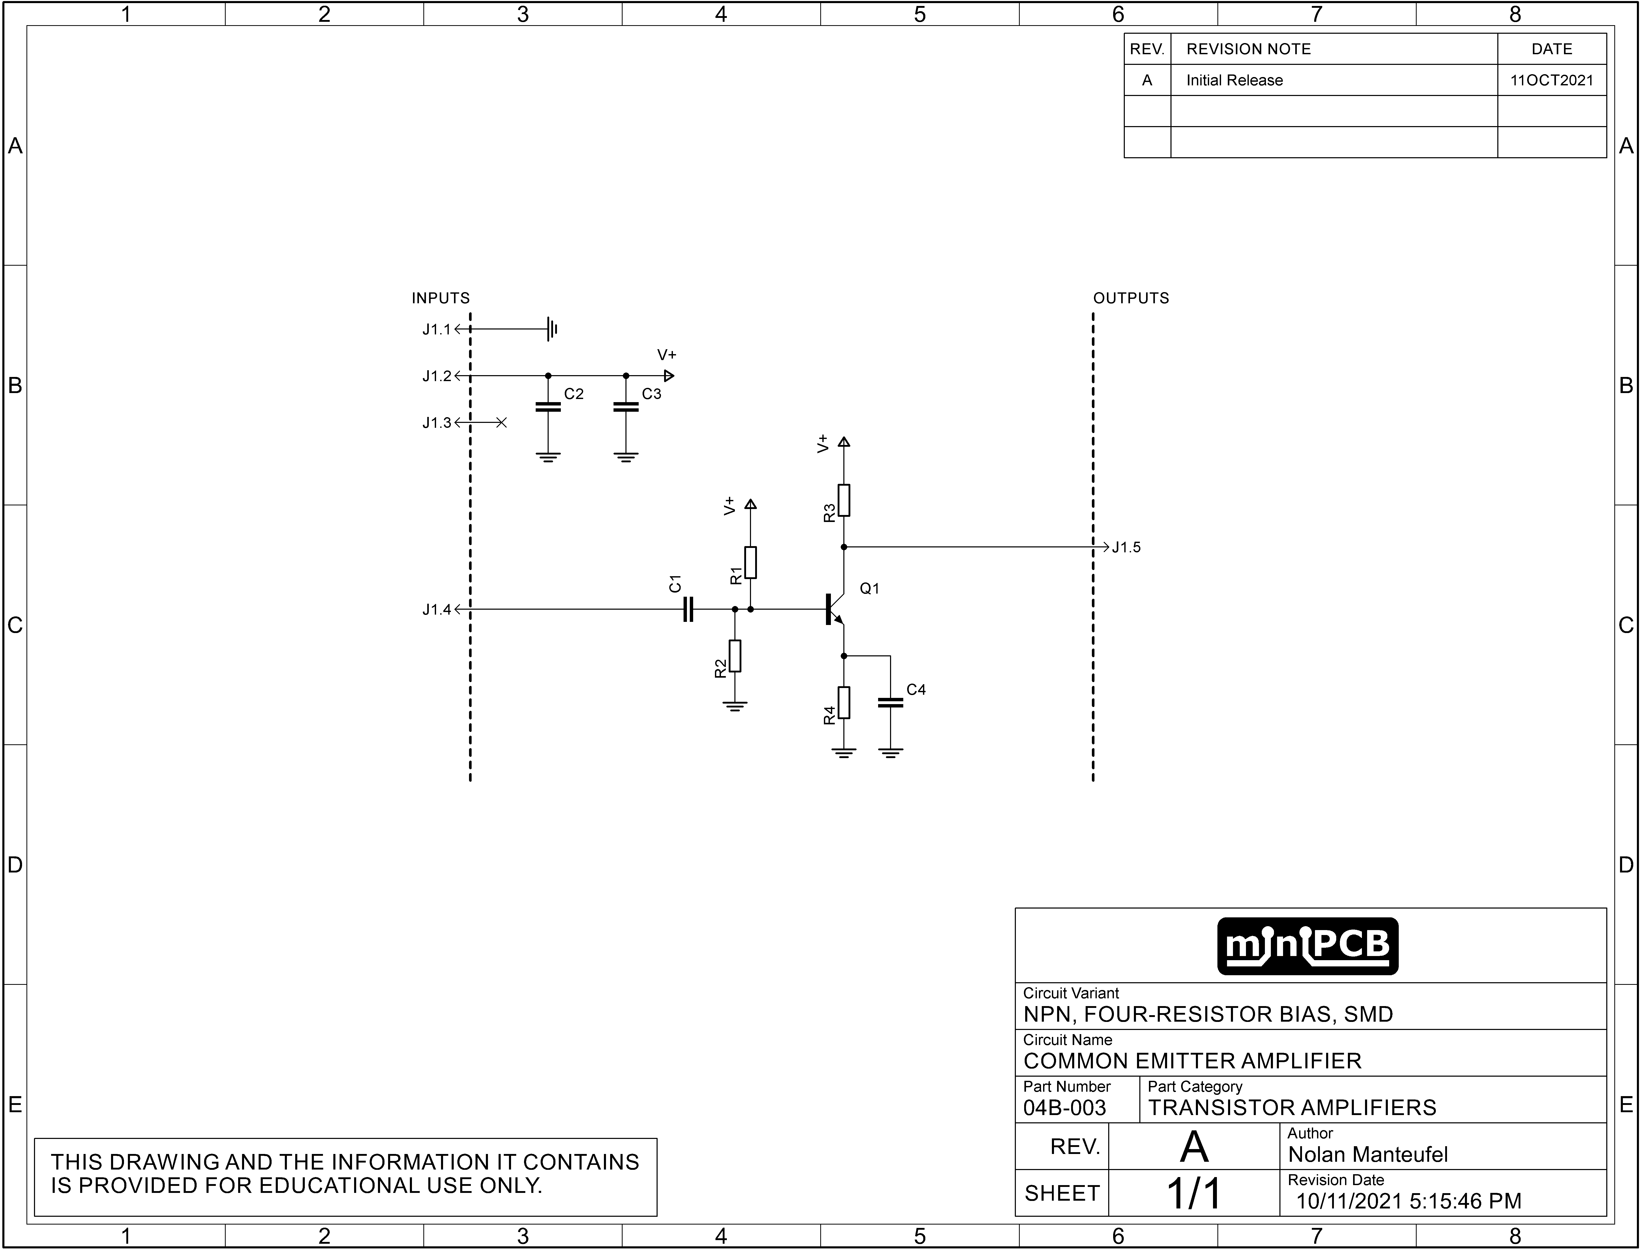

Design Steps
- Specify range of acceptable collector (drain) current.
- Specify supply voltage.
- Specify range of approximate gain (ratio of voltage between Vce and Vre?).
- Specify approximate transistor characteristics (BJT, MOSFET, etc.).
- Select a combination of resistor values that are readily available.

Parameter | Min | Target Value | Max | Unit
Collector Current | 1 | 10 | 20 | mA
Supply Voltage |  |  |  | V
Voltage Gain |  |  |  | V/V
Q1 Beta | 60 | 100 | 140 | A/A
Input Impedance |  |  |  | Ω
(Output Impedance) |  |  |  | Ω
(Quiescent Current) |  |  |  | mA

Design Outputs
 | Definition | Expression
Voltage Gain
Input Impedance
Output Impedance
Bandwidth

References
Doc. No. | Title | Source
#000-000 | miniPCB Datasheet | Github repository url
V000-000 | YouTube Video | YouTube video url

Revision History
Revision | Note | Date
A | Initial Release | YYYYMMDD

